

Department of Mechanical and Nuclear Engineering

Nuclear Reactor Theory
0407308

Final Examination Solution

Spring 2023-2024

Time/Date: 8:30 - 10:30, May 8, 2024
Room: W10-002
Instructor: Dr. Thanh Mai Vu

Student Name | Student ID

Rules:
- Begin by writing your name and student ID.
- Closed-book exam, only a calculator is allowed.
- Using mobile phone and smart watch during exam is not allowed. Any academic dishonesty will result in “F” for your final grade.
- Write the answer neatly and clearly. The result should be written with its unit.

For Instructor:

Question | 1 | 2 | 3 | 4 | 5 | 6 | Total
Grade
Out of | 6 | 6 | 6 | 6 | 15 | 6 | 45

Useful Equations:
One group NDE:
$$-D∇^{2}ϕ\left(r\right)+Σ_{a}ϕ\left(r\right)=\frac{1}{k}νΣ_{f}ϕ\left(r\right)$$
$$k_{eff}=\frac{νΣ_{f}}{DB^{2}+Σ_{a}}$$
$$P_{NL}=\frac{1}{1+B^{2}L^{2}}$$
$$D=\frac{1}{3Σ_{tr}}$$
Material Buckling
$$B_{m}^{2}=\frac{νΣ_{f}-Σ_{a}}{D}$$
The leakage to absorption ratio$=\frac{DB^{2}}{Σ_{a}}$
For cylindrical geometry:
$$B^{2}={\left(\frac{2.405}{R}\right)}^{2}+{\left(\frac{π}{H}\right)}^{2}$$
$$ϕ\left(r,z\right)=AJ_{0}\left(\frac{2.405}{R}r\right)\cos\left(\frac{π}{H}z\right)$$
The average neutron flux in the reactor.
$$ϕ_{avg}=\frac{P}{E_{R}Σ_{f}V}$$

$$\frac{ϕ_{max}}{ϕ_{avg}}=3.64$$

Problems:
- (Total 6 points)
a. (2 points) What is reaction rate?
Solution:
The reaction rate is the number of interactions taking place in one cubic centimeter per one second.

- b. (4 points) A monoenergetic beam of neutrons,$ϕ$ = 4 × 10¹⁰ neutrons/cm²-sec, impinges on a target 1 cm² in area and 0.1 cm thick. There are 0.048 x 10²⁴ atoms per cm³ in the target, and the total cross-section at the energy of the beam is 4.5 b.
Calculate the macroscopic total cross-section and number of neutron interactions per second occur in the target.

Solution:
- The macroscopic total cross-section:
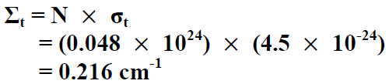

- Number of neutron interactions per second occur in the target:
${Number of reaction=}_{t}V=$8.64*${10}^{8}(\frac{interaction}{s})$

- (Total 6 points)

a. (3 points) Write the 4-factor formula and define each factor
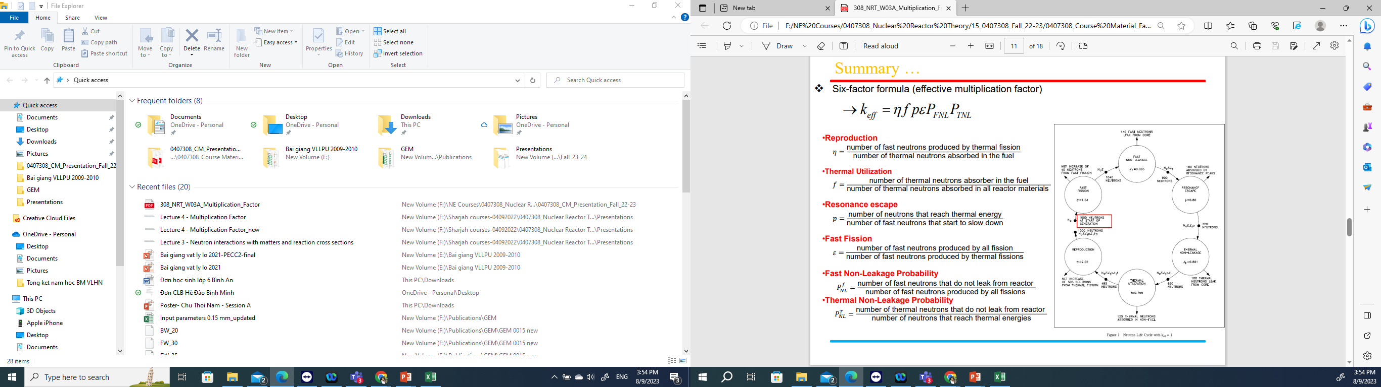
Solution:
Four factor formula
$$k_{∞}=ηpfε$$

b. (3 points) In a thermal nuclear reactor at the beginning of its life for every 1,000 neutrons, 500 neutrons are absorbed in ²³⁵U, 225 neutrons are absorbed in ²³⁸U, 125 neutrons are absorbed in coolant and cladding, 150 neutrons leak out from the geometrical core boundaries, and ν is 2.43.
Calculate the multiplication factor and the conversion ratio value for this reactor

Solution:
Assume that all neutrons absorbed in U235 cause fission reaction, the multiplication factor of the reactor is:
k₁ =500*2.43/1000=1.215
The conversion ratio value for this reactor?
$CR=\frac{\text{Fissile Material Produced}}{\text{Fissile Material Destroyed}}$=$\frac{\text{225}}{\text{500}}$=0.45

- (Total 6 points)
a. (3 points) Complete the following neutron transport equation:
Leakage
Source
$$\frac{1}{v}\frac{∂ϕ}{∂t}+ \text{ +}Σ_{t}\left(r,E\right)ϕ\left(r,E,\hat{Ω}, t\right)=$$
$$+$$
In-scattering

Solution:
$$\frac{1}{v}\frac{∂ϕ}{∂t}+\hat{Ω}∙∇ϕ(r,E,\hat{Ω},t\text{) +}Σ_{t}\left(r,E\right)ϕ\left(r,E,\hat{Ω}, t\right)$$
$$=\int_{4π}{d{\hat{Ω}}^{'}}\int_{0}^{∞}{dE^{'}}Σ_{s}\left(E^{'}→E,{\hat{Ω}}^{'}→\hat{Ω}\right)ϕ\left(r,E^{'},{\hat{Ω}}^{'}, t\right)+s\left(r,E,\hat{Ω},t\right)$$
b. (3 points) Three isotropic neutron sources, each emitting S neutrons/sec, are located in an infinite vacuum at the three corners of an equilateral triangle of side a.
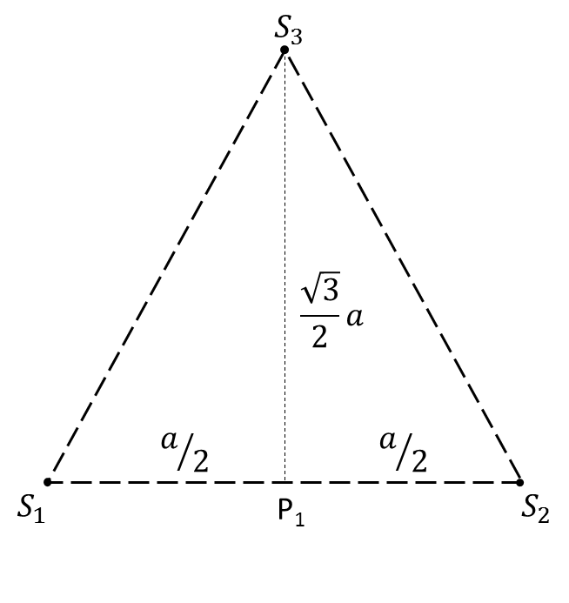
Find the flux at P₁ - the midpoint of one side.

Flux of point source in infinite medium:
$$ϕ\left(r\right)=\frac{S}{4πDr}e^{-r/L}$$

Solution:

Total flux at position P₁:
$$ϕ\left(P_{1}\right)=2×\frac{S}{4πD\left(\frac{a}{2}\right) }e^{-\frac{a}{2L}}+\frac{S}{4πD\left(\frac{\sqrt{3}a}{2}\right)}e^{-\frac{\sqrt{3}a}{2L}}=\frac{S}{πDa}\left(e^{-\frac{a}{2L}}+\frac{e^{-\frac{\sqrt{3}a}{2L}}}{2\sqrt{3}}\right)$$

- (Total 6 points) A plane source of strength $S_{o}$ neutrons/sec is placed in an infinite medium. The material has an absorption cross section $Σ_{a}$ and a diffusion coefficient $D$. Neglect the extrapolation distance.
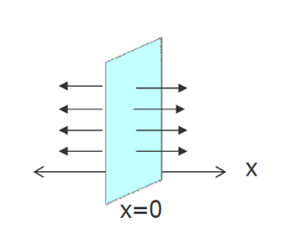
  - (3 points) Write down the diffusion equation and its general solution for this problem for
$x≠0$.

Solution:

$$L^{2}=\frac{D}{Σ_{a}}$$
$$∇^{2}ϕ\left(x\right)-\frac{1}{L^{2}}ϕ\left(x\right)=-\frac{S\left(x\right)}{D}$$
$$→\frac{d^{2}ϕ(x)}{dx^{2}}-\frac{1}{L^{2}}ϕ\left(x\right)=0, x≠0$$
General solution: $ϕ(x)=Ae^{-x/L}+Ce^{x/L}$
  - (3 points) Solve the general equation for $ϕ(r)$ by applying 2 following conditions:
$$\lim_{x→∞}{ϕ(x)}=0$$
$$\lim_{x→0}{J\left(x\right)}=\frac{S_{0}}{2}$$
Solution:

Applying physical condition:
$$\lim_{x→∞}{ϕ(x)}=0$$
$$\lim_{x→∞}\left\{Ae^{-x/L}+Ce^{x/L}\right\}=0, then C=0$$
$$∴ϕ(x)=Ae^{-x/L}$$
Applying source condition:
$$\lim_{x→0}{J(x)}=\frac{S_{0}}{2}$$
Determine $A$: From Fick’s law:
$$J\left(x\right)=-D\frac{dϕ}{dx}=-D\frac{d\left(Ae^{-x/L}\right)}{dx}$$
$$J\left(x\right)=\frac{DA}{L}e^{-x/L}, x>0$$
Then
$$\lim_{x→0}{J(x)}=\lim_{x→0}{\frac{DA}{L}e^{-x/L}}=\frac{DA}{L}=\frac{S_{0}}{2}→A=\frac{S_{0}L}{2D}$$
$$∴ϕ\left(x\right)=\frac{S_{0}L}{2D}e^{-x/L}, x>0$$
Final solution:$ϕ\left(x\right)=\frac{S_{0}L}{2D}e^{-{|x|}/L}$

- (Total 15 points)
For a cylindrical shape reactor with the following information:

- Initial boron concentration = 2200 ppm
- $σ_{a}$ of Boron = 600 b, $σ_{tr}$ of Boron = 0 b.
- Mass number of boron = 10.811
- For water, $Σ_{a}$=0.035 /cm, $Σ_{f}$=0.00 /cm, $Σ_{tr}$=0.050 /cm
- For fuel, $Σ_{a}$=0.650 /cm, $Σ_{f}$=0.40 /cm, $Σ_{tr}$=0.040 /cm, $υ$=2.5
- Fuel to Moderator volume ratio= 1/3
- Avogadro number = 6.022x10²³ atom/mole
- Power=1000 MWth
- Do not neglect the extrapolation distance.

Answer the following equation using 1-group diffusion theory:

  - (2 points) Calculate $Σ_{a}^{t}$ for a mixture of fuel, water, and boron.
$$N^{B}=\frac{2200 g}{{10}^{6} g}=\frac{2.2×{10}^{-3}}{10.811 g/mole}×0.6022×{10}^{24}atom/mole$$
$$N^{B}=1.225×{10}^{20}\frac{atom}{g}≈1.225×{10}^{-4}\frac{atom}{b cm}$$
$$Σ_{a}^{B}=N^{B}σ_{a}=0.074 cm^{-1}$$
$$Σ_{a}=0.244 cm^{-1}$$

  - (2 points) Calculate the diffusion coefficient.
$$D=\frac{1}{3Σ_{tr}}=7.092 cm$$

  - (2 points) Find a geometrical buckling that makes the reactor critical.
$$B_{g}^{2}=B_{m}^{2}=\frac{νΣ_{f}-Σ_{a}}{D}=8.699×{10}^{-4} cm^{-2}$$

  - (3 points) If the diameter of the reactor is 150 cm, calculate the critical height of cylinder.
$$d=0.71×3D=14.947$$
$$B_{r}^{2}={\left(\frac{2.405}{R+d}\right)}^{2}=7.149×{10}^{-4} cm^{-2}$$
$$B_{m}^{2}=B_{g}^{2}=B_{r}^{2}+B_{z}^{2}$$
$$B_{z}^{2}=1.550×{10}^{-4} cm^{-2}$$
$$H=\frac{π}{B_{z}}-2d=222.462 cm$$

  - (2 points) Calculate the leakage to absorption ratio.
$$=\frac{DB^{2}}{Σ_{a}}=0.103$$

  - (2 points) Calculate the average neutron flux in the reactor.
$$ϕ_{avg}=\frac{P}{E_{R}Σ_{f}V}=7.949×{10}^{13} neutrons/cm^{2}s$$

  - (2 points) Calculate the maximum neutron flux in the reactor.

$$ϕ_{max}=ϕ_{avg}×3.64=2.894×{10}^{14} neutrons/cm^{2}s$$

- (Total 6 points) Diffusion equation for group g is written as follows:

$$\frac{1}{v_{g}}\frac{∂ϕ_{g}\left(\vec{r},t\right)}{∂t}-\vec{∇}⋅D_{g}\left(\vec{r}\right)\vec{∇}ϕ_{g}\left(\vec{r},t\right) +{Σ_{t}}_{g}\left(\vec{r}\right)ϕ_{g}\left(\vec{r},t\right)$$

$$= χ_{g}\sum_{g^{'}=1}^{G}{ν{Σ_{f}}_{g^{'}}(\vec{r})ϕ_{g^{'}}(\vec{r},t)} +\sum_{g^{'}=1}^{G}{ }Σ_{s_{g'→g}}(\vec{r})ϕ_{g^{'}}(\vec{r},t)+ S_{g}(\vec{r},t)$$

a. (3 points) Explain the meaning of each term of the equation
b. (2 points) Write down the multigroup diffusion equation for steady-state condition.
c. (1 point) Write down the steady-state multigroup diffusion equation in case the fission source is much more dominant compared to the external source.

Solution:
a.
Leakage
Total interaction
Fission source
Scattering in
External source
Rate of change in neutron flux
$$\frac{1}{v_{g}}\frac{∂ϕ_{g}\left(\vec{r},t\right)}{∂t}-\vec{∇}⋅D_{g}\left(\vec{r}\right)\vec{∇}ϕ_{g}\left(\vec{r},t\right) +{Σ_{t}}_{g}\left(\vec{r}\right)ϕ_{g}\left(\vec{r},t\right)$$

$$= χ_{g}\sum_{g^{'}=1}^{G}{ν{Σ_{f}}_{g^{'}}(\vec{r})ϕ_{g^{'}}(\vec{r},t)} +\sum_{g^{'}=1}^{G}{ }Σ_{s_{g'→g}}(\vec{r})ϕ_{g^{'}}(\vec{r},t)+ S_{g}(\vec{r},t)$$

b. For steady-state condition:
$$-\vec{∇}⋅D_{g}(\vec{r})\vec{∇}ϕ_{g}(\vec{r}) +{Σ_{t}}_{g}(\vec{r})ϕ_{g}(\vec{r}) = χ_{g}\sum_{g^{'}=1}^{G}{ν{Σ_{f}}_{g^{'}}(\vec{r})ϕ_{g^{'}}(\vec{r})} +\sum_{g^{'}=1}^{G}{ }Σ_{s_{g^{'}→g}}(\vec{r})ϕ_{g^{'}}(\vec{r})+ S_{g}(\vec{r})$$
c. Neglecting the external source:
$$-\vec{∇}⋅D_{g}(\vec{r})\vec{∇}ϕ_{g}(\vec{r}) +{Σ_{t}}_{g}(\vec{r})ϕ_{g}(\vec{r}) = χ_{g}\sum_{g^{'}=1}^{G}{ν{Σ_{f}}_{g^{'}}(\vec{r})ϕ_{g^{'}}(\vec{r})} +\sum_{g^{'}=1}^{G}{ }Σ_{s_{g^{'}→g}}(\vec{r})ϕ_{g^{'}}(\vec{r})$$

